use bank_database_cs154;

insert into branch values('SBI_MantriMarg','Delhi',200000);

insert into Depositer values('Nikhil',12);

create table Borrower(

name varchar(20),

loan_number varchar(20),

primary key(name,loan_number),

foreign key (name) references BankCustomer(name),

foreign key (loan_number) references Loan(loan_number));

insert into Borrower values("Avinash",1);

insert into Borrower values("Dinesh",2);

insert into Borrower values("Mohan",3);

insert into Borrower values("Nikhil",4);

insert into Borrower values("Ravi",5);

select * from Borrower;

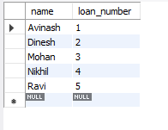

select distinct d.name from Depositer d,

BankAccount ba,branch b

where d.accno=ba.accno and

ba.branch_name=b.branch_name and b.city="Delhi"

group by d.name having count(b.branch_name)>1;



select b.name from Borrower b

where b.loan_number not in

(select d.accno from Depositer d

where b.loan_number =d.accno);



select b.name from Borrower b

where b.loan_number in

(select d.accno from Depositer d,

BankAccount ba,branch b

where b.loan_number=d.accno and d.accno and ba.branch_name=b.branch_name

and b.city="Bangalore");



select branch_name from branch

where assets_inlakhs>all

(select assets_inlakhs from branch where

city="Bangalore");

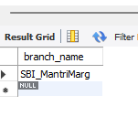

delete from BankAccount ba where ba.branch_name=

(select b.branch_name from branch b

where city ="Bombay");

select * from BankAccount;

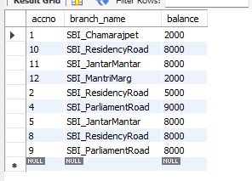

update BankAccount

set balance=balance+ ((5*balance)/100)

where accno in (1,2,4,5,8,9,10,11,12);

select * from BankAccount;

